
Data Management - Data Mining Research
Optimizing Social Commerce: An Association Rule Mining Approach to Market Basket Analysis on TikTok Shop
Module Code | CT075-3-2-DTM-L-3
Lecturer | Dr. Murugananthan Velayutham
Intake Code | APD2F2509CS(DA)
Date Assigned | 01 October 2025
Date Completed | 11 December 2025
Student / TP Number | Roger Rusdijanto Purnomo / TP075718

Table of Contents

1. Introduction 3
2. Motivation For Using Data Mining in TikTok Shop Market 4
3. Problem Statement 5
3.1. Users Buying Experience Optimization Problem 5
3.2. Vendors Sales Market Target 5
4. Data Mining Technique and Approaches Used to Resolve the Problems 5
4.1. Association Rule Mining Usage 5
4.2. Aims 6
4.3. Processes 6
4.4. Association Rule Mining and Market Basket Analysis 8
4.5. Problem Resolved 9
5. The Evaluation Method of Data Mining Model 9
6. Opportunities Produced by the Analysis 10
7. Challenges Faced 11
8. Future Direction of Research 12
9. Conclusion 12
10. References 14

Introduction
The rapid changes in digital has affected the way people behave and interact with the commercial market. With the appearance of e-commerce, there is an easier way to buy things. Nowadays customers tend to buy things online rather than going into the store because it is less time-consuming and flexible to be done whenever and from anywhere. It has evolved into a critical component of the global economy, driven by technological advancements and shifting consumer behaviors toward convenience and personalization (Rane, 2025). The current trend in this domain is characterized by rapid expansion; global retail e-commerce sales are projected to reach approximately $7.4 trillion by 2025, accounting for nearly 24% of total retail sales worldwide (Fedyshyn et al., 2021). This indicates that the e-commerce sector is growing and dominating alongside the increasing number of digital interactions daily.
Data mining is defined as the computational process of extracting non-obvious, useful information and patterns from large datasets using statistical analysis and machine learning techniques (Goletsis et al., 2025). It aims to interpret raw data, transforming them into an eligible information that contains specific information for specific purposes. It detects hidden relationships, anomalies, and even trends that humans cannot detect by themselves. By leveraging these techniques, organizations can predict future outcomes and solve complex operational problems, effectively turning enormous data into strategic assets for decision-making (Sinha, 2021).
The purpose of applying data mining in this domain is to help both customers and sellers get their benefits. For customers, their individual preferences can be found with data mining to increase their personal shopping experience. On the other hand, For sellers their sales can be improved by finding the customers’ behaviour and buying habits to determine the specified business strategy. If both customers and sellers are fulfilled with excitement, it will be good for the entire e-commerce ecosystem as well, keeping the environments stable and convincing.

Motivation For Using Data Mining in TikTok Shop Market
Data mining plays a huge role in the e-commerce domain especially in this case, the TikTok market shop, as it helps to analyze impulse co-purchase patterns and content-driven associations. TikTok Shop requires dynamic analysis of real-time metrics such as viewer retention rates, comment sentiment, and live-stream engagement peaks to understand market viability (Sari et al., 2025).
The main reason for using data mining in the TikTok Shop market is because it is discovery-driven and impulse-driven, rather than search-driven like traditional e-commerce platforms such as Amazon and other marketplaces. It means that TikTok has the advantage of having additional crucial data while it allows users to discover the product by themselves based on the algorithm, which is built to act as a powerful recommendation engine, learning their unique interests by analyzing interactions from users and videos. For example, data generated through short videos, live streams, and community interactions that are not discoverable on search-driven platforms. This capability enables the platform to identify emerging viral trends and product flaws instantly, helping sellers pivot their strategies to align with the rapidly shifting "shoppertainment" landscape (Hidayat et al., 2023).
Furthermore, data mining significantly enhances decision-making for both users and the TikTok Shop marketplace through predictive analytics and Market Basket Analysis (MBA). For users, recommender systems powered by collaborative filtering reduce the cognitive burden of choice by curating a personalized feed that aligns with their hidden preferences, effectively guiding their purchasing decisions (Zhang, 2024). For sellers and the platform, MBA techniques such as the Apriori algorithm are utilized to uncover latent associations between products, predicting current and future sales trends by identifying items frequently purchased together (Kumar & Shah, 2025). This predictive capability allows merchants to optimize inventory and bundle products strategically, ensuring that decision-making is aligned with the projected future trends.

Problem Statement

3.1. Users Buying Experience Optimization Problem
Sometimes, users do not realize that they need to purchase certain products to support their secondary or tertiary needs until it pops up on their screen. The ”unknowingly needed” needs and impulsive buying that do not match their needs become a problem for users.

3.2. Vendors Sales Market Target
For vendors, sales increase when it reaches the right market target, but it is quite hard to achieve it. For example, cosmetics vendors aim to reach the girls' youth, but the users of TikTok app varies across different generations and genders, with their own specific interests as well, making it hard to reach the right market target.

Data Mining Technique and Approaches Used to Resolve the Problems

4.1. Association Rule Mining Usage
Association Rule Mining (ARM) is the most suited data mining technique to be used in this particular domain of TikTok Shop e-commerce. The reason why is because of its ability to process high-volume transactional data rapidly and precisely .TikTok Shop transactions, often initiated through live stream purchases or video recommendations, represent spontaneous buying decisions rather than pre-planned shopping trips (Wijaya et al., 2025). ARM does not focus on the customer’s demographic, rather it focuses on the co-occurrence patterns in the sales data. Meaning that ARM aims to analyse the pattern of what customers buy, including their combination of products, for example customers who buy beers tend to buy peanuts alongside. It efficiently discovers the specific product combinations purchased by customers, revealing the buying habits on certain products. This technique directly supports the discovery-driven nature of TikTok, identifying non-obvious relationships between seemingly unrelated items (in example, a viral face mask and a trending snack).

4.2. Aims
ARM aims to conduct strong rules that describe the co-occurrence relationships between itemsets. An association rule is typically expressed in the format X→Y (If a user buys X, then they are likely to buy Y) (Agrawal et al., 1994). This method is used to find the dependencies of items bought by the customers.

4.3. Processes
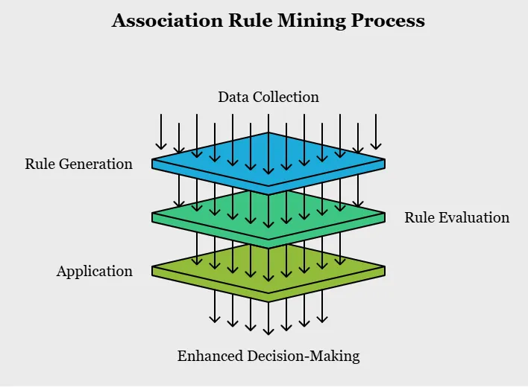
Figure 4.3.1. General Association Rule Mining Process Overview
The ARM process is commonly executed through the Apriori or FP-Growth algorithms, includes two steps:
1. Frequent Itemset Generation
The goal is to find which combination of items that are brought together frequently. When the number of distinct items increases, so does the number of possible combinations (itemset).
A. The Apriori Algorithm (The Foundational Approach)
It operates based on the Anti-Monotonicity Principle: if an itemset is frequent, all of its subsets must also be frequent.
- Process: The idea of Apriori Algorithm uses an iterative, bottom-up approach, building candidate itemsets (Ck​) from the frequent itemsets of the previous step (Lk−1​). This helps to significantly reduce the number of item combinations that need to be evaluated.
- Efficiency: It is very efficient whereas any subsets of candidate itemsets (Ck) that are not found in the previous frequent set are eliminated immediately, then continue to do a full scan of the database to count the support of the remaining candidates. Therefore, the candidates which meet the minimum support will become the frequent itemsets and used in the repeated process to find (Lk+1).
B. The FP-Growth Algorithm (The Optimized Approach)
Frequent Pattern Growth is another way to cover the inefficiency of Apriori, where it does not require to do a full scan of the database unlike Apriori, making it more efficient and less time-consuming especially for a large dataset.
- Process: FP-Growth scans the database twice. First, it counts item frequencies. Second, it compresses the data into a specialized data structure called the Frequent Pattern Tree.
- Rule Generation: It then uses a recursive strategy on the FP-Tree to extract all frequent itemsets directly, eliminating the need for explicit candidate generation and reducing input and output operations (Han, Pei, & Yin, 2000).
2. Association Rule Generation
The algorithm creates strong association rules (X→Y) from all frequent itemsets after they have been identified. Minimum Support (min_sup) and Minimum Confidence (min_conf) are two components that need to be accompliced in order for the rule to be defined as strong.
The market baskets are the transactional data produced by video sales and live commerce sessions. ARM determines which products have the greatest sales lift when purchased sequentially or in combination. For example, ARM offers actionable intelligence in the condition if it finds a strong rule: ViralBeers→SnackPeanuts. This knowledge enables the TikTok Shop market to improve its platform-wide recommendation engine, making sure that the peanut snacks are displayed in the suggested shopping carousel when a user watches a video about beers.

4.4. Association Rule Mining and Market Basket Analysis
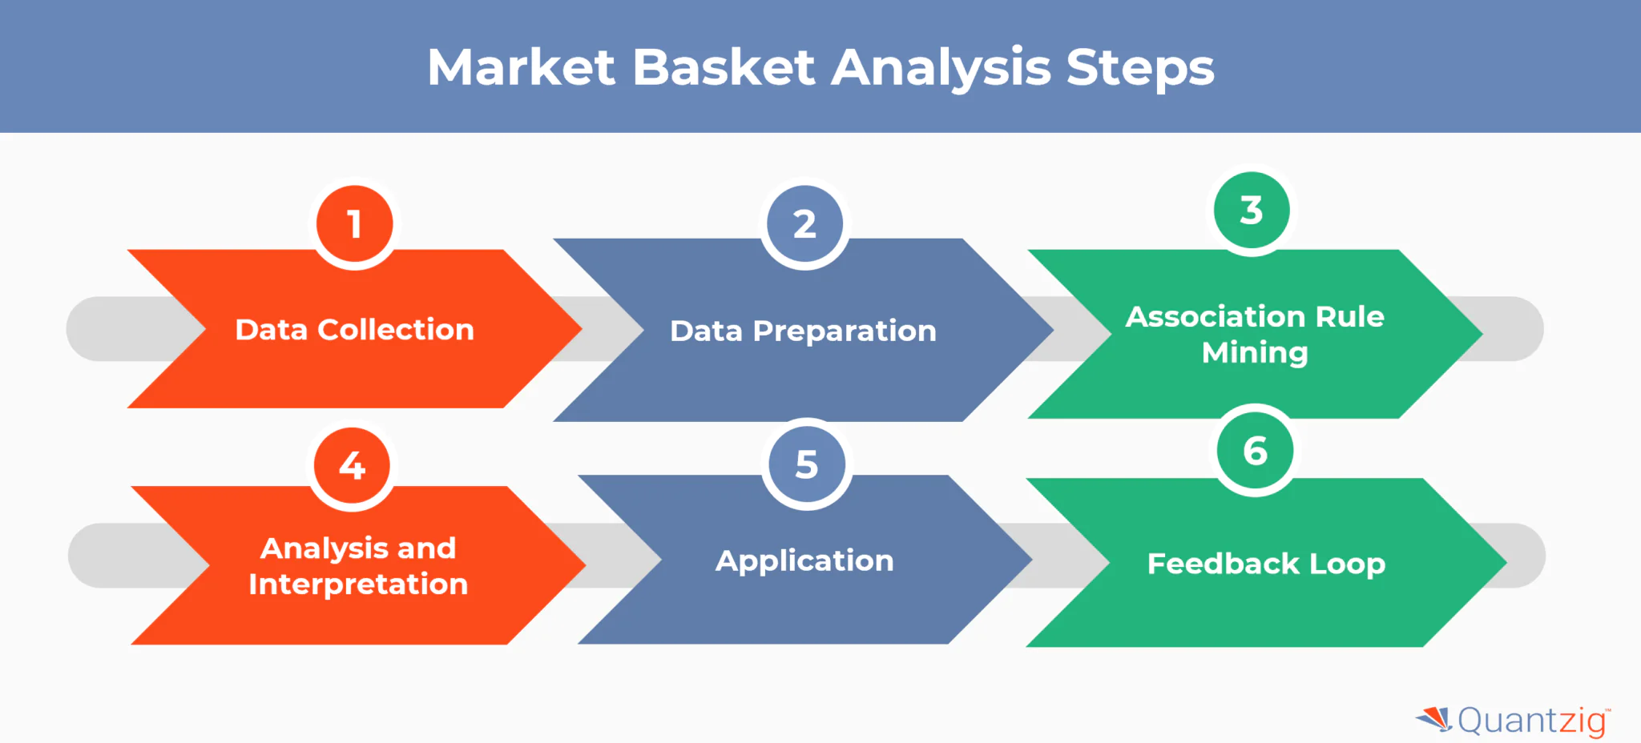
Figure 4.4.1. Market Basket Analysis Steps Overview
The term Market Basket Analysis (MBA) is not a distinct data mining technique but the business application or approach that utilizes Association Rule Mining (ARM). MBA is the overarching strategy used by vendors to understand the composition of a customer's 'basket' of goods to drive cross-selling and upselling (Mahajan et al., 2025). Thus, MBA is the goal, and ARM is the algorithm used to achieve that goal by generating the underlying association rules.

4.5. Problem Resolved
The combination of ARM/MBA provides crucial data and value for both users and vendors in the TikTok Shop market. For users, ARM-derived recommendations enhance the impulse-driven shopping experience by providing relevant, personalized suggestions, making the checkout process more seamless and reducing search friction (Zhang, 2024). For the TikTok Shop market and its vendors, MBA results are used to maximize their sales by optimizing product bundling, promotional pricing, and especially product placement within the video and live-stream interfaces. By predicting future trends based on frequent itemsets, vendors can manage inventory, while the platform can maximize revenue by intelligently curating the "For You" shopping experience.

The Evaluation Method of Data Mining Model
The evaluation of Association Rule Mining (ARM) is a critical step because the process often yields an excessively large number of rules, many of which are statistically strong but practically uninteresting or redundant (Tan & Kumar, 2024; MDPI, 2020). The evaluation method therefore focuses on the interestingness of the rules. There are three key metrics in the evaluation method:
- Support: It is the frequency of the itemsets X and Y occurring together relative to all transactions, indicating popularity.
- Confidence: It is the probability that Y is bought when X is bought, indicating the relevancy of the rule.
- Lift: It is a measurement of the strength of the association, showing how much more likely X and Y are to be bought together than if they were statistically independent (Kumar & Shah, 2025).
In the context of the TikTok Shop, the evaluation must look beyond high Support to find rules with high Lift and Subjective Utility that capture emerging, non-obvious social trends.

Opportunities Produced by the Analysis
1. Maximized Vendor Profitability and Revenue Generation
The most direct benefit of ARM/MBA is the ability to drive higher transaction values and frequency for vendors on TikTok Shop.
- Optimized Cross-Selling and Product Bundling: In this case, ARM can identify what are the combinations of products that are mostly ordered by customers. It can be crucial information for sellers to create a bundle in accordance with the information gathered.
- Targeted Inventory and Merchandising: By acknowledging the combinations of products often bought by customers, sellers can start to sort the products that do not match customers’ interest.
- Dynamic Pricing and Promotion Strategy: ARM helps identify the price of products and how the correlation between unit price and products sold is. Enabling sellers to acknowledge customers’ buying habits. All of these information builds the foundation of great business strategy.
2. Enhanced and Personalized User Shopping Experience
In the discovery-driven environment of TikTok Shop, data mining ensures that the platform remains engaging and relevant to the individual user, enhancing their personal shopping experience.
- Impulse-Driven Personalization: Unlike traditional search-driven platforms, ARM directly informs the platform's proprietary recommendation algorithms (Zhang, 2024). By analyzing customers’ behaviour on watching videos of specific categories, the system can recommend the most accurate and corresponding to their interest, increasing the overall shopping experience in TikTok platform.
- Reduced Decision Fatigue: The huge number of product catalogues can be an overwhelming issue for customers to choose which one to buy, what they want and what they actually need. By using ARM, the system can act as a filter, offering relevant products only to specific customers. At last, it improves their confidence in buying certain products.
3. Operational and Analytical Efficiency for TikTok
Beyond direct sales, these techniques provide critical analytical intelligence that refines the underlying structure of the marketplace.
- Forecasting Future Trends: ARM provides predictive capability which is crucial for the TikTok Shop market, allowing the platform itself to adapt its merchandising categories and partner strategies ahead of the competition.
- Optimized Platform Layout: The data informs the optimal placement and grouping of products not just for bundles, but for the actual digital layout of the shop user interfaces. Products found to be strongly associated can be grouped together within the platform to encourage natural cross-shopping.

Challenges Faced
There is not any single data mining techniques that can guarantee a hundred percent success, there may appear some challenges when trying to implement Association Rule Mining into the TikTok Shop Market, such as:
- Computational Complexity and Scalability
E-commerce platforms like TikTok shop itself provides millions of transactions daily. By using the ARM which includes the algorithm like Apriori in the process, it can consume a lot of memory of the system, creating poor performance and possible data clashes.
- Rule Interpretation
In a trend-driven market like TikTok Shop, rules become crucial as it determines how the algorithm will work. Too many rules can create a clash, redundancy, and not genuinely actionable. On the other hand, in rapid changes of trends over time, some old rules and data can become irrelevant.
- Data Handling
Data sparsity can be a problem in the implementation of ARM. When the number of products is very large, the transactional matrix is extremely sparse, meaning most itemsets have zero support. It will prevent data interpretation and confuse the algorithm into creating a wrong recommendation for users.

Future Direction of Research
Aside from the benefits of Association Rule Mining technique on its implementation into TikTok Shop Market, there is still room for improvements to enhance overall capabilities of the system and cover the downside of possible challenges faced.
Nowadays, e-commerce is still improving rapidly, both from the users and customers side. The amount of data collected daily is not small as well, therefore there needs to be a solution to support data handling to ensure the system’s accuracy on analyzing and delivering information to both customers and sellers. Future direction must put customers’ shopping experience and sellers' satisfaction in front. The implementation of Artificial Intelligence can be considered as it will help the Machine Learning process and reduce the amount of work needed to be done by the system. Therefore data handling, data quality, and rule interpretation of the system can be improved in terms of scalability, accuracy, and effectiveness.

Conclusion
In conclusion, data mining techniques play a significant role in determining the smoothness of a system. In this case Association Rule Mining is highly suitable for discovery-driven e-commerce marketplace like TikTok Shop , rather than traditional marketplace which uses search-driven. Because TikTok Shop is integrated inside of the TikTok app, then ARM can be used in terms of algorithm for product recommendation purposes. It is a data mining technique that uses rule interpretation based on the processed data imported from users’ behaviour on TikTok contents they watch regularly, indicating specific customer’s interest, which then creates an important pattern. The ARM is then used in the Market Basket Analysis to identify the customers’ pattern of product combination buying habits. Both ARM and MBA are not distinct, rather MBA is the business application or approach that utilizes Association Rule Mining.
On the other hand, there may appear some limitations on using ARM in the TikTok Shop ecosystem, the majority is in the data handling problem due to the huge amount of data collected daily, which I believe will increase massively over time. Therefore there needs to be a future enhancement using the implementation of Artificial Intelligence to help improve the Machine Learning process and reduce the amount of work done by the system itself. Enhancement must be accomplished without forgetting the initial scope of enhancing customers’ experience and sellers’ satisfaction over time.

References
1. Agrawal, R., & Srikant, R. (1994). Fast algorithms for mining association rules in large databases. Proceedings of the 20th International Conference on Very Large Data Bases, Santiago de Chile, 487–499. https://www.vldb.org/conf/1994/P487.PDF
2. Han, J., Pei, J., & Yin, Y. (2000). Mining frequent patterns without candidate generation. SIGMOD Record (ACM Special Interest Group on Management of Data), 29(2), 1–12. https://scholars.duke.edu/individual/pub1530879
3. Manda, V. K., Kumar, C. S., & Pothuri, V. S. (2019). Market Basket Analysis for Sales Transaction in Shopping Stores. International Journal of Academic Research in Business and Social Sciences, 9(12), 1–13. https://hrmars.com/papers_submitted/15439/market-basket-analysis-for-sales-transaction-in-shopping-stores.pdf
4. Whahidi, R., & Ismailova, I. (2024). Association rule mining algorithm implementation for e-commerce in the retail sector. Journal of Applied Research in Technology & Engineering, 5(2), 63–68. https://www.researchgate.net/publication/379844429_Association_rule_mining_algorithm_implementation_for_e-commerce_in_the_retail_sector
5. Agrawal, R., Imielinski, T., & Swami, A. (1994). Mining Association Rules between Sets of Items in Large Databases. ACM SIGMOD Record, 22(2), 207–216. https://doi.org/10.1145/170036.170072
6. Fedyshyn, I. B., Padovska, O. V., & Tymovchak-Maksymets, O. I. (2021). Analysis of the Main Global Trends for E-Commerce. Socio-Economic Problems and the State. http://sepd.tntu.edu.ua/images/stories/pdf/2021/21fibmge.pdf
7. Goletsis, Y., Kyprianou, C., & Chin, T. (2025). The hidden machinery of entrepreneurial culture: a data mining approach. Journal of Intellectual Capital, 26(2), 345–368. https://www.emerald.com/jic/article/doi/10.1108/JIC-04-2025-0125/1325349/The-hidden-machinery-of-entrepreneurial-culture-a
8. Han, Y. (2024). The Impact of Personalized Recommendations on Consumer Purchase Decisions on TikTok – A Case Study of College Students. Interdisciplinary Humanities and Communication Studies, 2(6). https://www.deanfrancispress.com/index.php/hc/article/view/552
9. Hidayat, A., & Rizki, M. (2023). Users Opinion Mining of TikTok Shop Social Media Commerce to Find Business Opportunities. Journal of Theoretical and Applied Information Technology, 101(01), 214–223. http://www.jatit.org/volumes/Vol101No1/18Vol101No1.pdf
10. Kumar, A., & Shah, R. (2025). Data Mining Techniques for Retail Market Analysis: Unveiling Customer Insights and Enhancing Business Strategies. Liberte Journal, 13(1), 100–106. https://liberteresearch.org/wp-content/uploads/8-LBRJ2136.pdf
11. Mahajan, R., Nandi, S., Kumar, A., & Kaur, G. (2025). Evaluating the Economic Impact of E-commerce through Data Mining Techniques. European Economic Letters (EEL), 15(1), 899–906. https://doi.org/10.52783/eel.v15i1.2466
12. Rane, N. (2025). Growth in European E-Commerce: Analyzing the Surge in Online Shopping. Global Scientific Journal, 13(9). https://www.globalscientificjournal.com/researchpaper/GROWTH_IN_EUROPEAN_E_COMMERCE_ANALYZING_THE_SURGE_IN_ONLINE_SHOPPING_AND_CONSUMER_BEHAVIOUR.pdf
13. Sari, I. P., & Hartono, A. (2025). Sentiment Analysis on TikTok Shop Reviews Using Long Short-Term Memory Method. International Journal of Artificial Intelligence & Robotics, 1(2). https://www.researchgate.net/publication/383243932_Sentiment_Analysis_on_TikTok_Shop_Reviews_Using_Long_Short-Term_Memory_Method_to_Find_Business_Opportunity
14. Sinha, R. (2021). A Study on Importance of Data Mining in Information Technology. International Journal of Engineering and Applied Sciences, 8(6), 195–198. https://www.researchgate.net/publication/352178543_A_Study_on_Importance_of_Data_Mining_in_Information_Technology
15. Wijaya, A. P., & Santoso, B. (2025). The Impact of TikTok Live Information on Impulsive Buying Behavior. Journal of Economics and Business, 8(1), 133–140.https://ejournal.seaninstitute.or.id/index.php/Ekonomi/article/download/5769/4610
16. Zhang, L. (2024). Personalized Marketing and Recommendation Systems on TikTok: A Literature Review. Advances in Engineering Innovation, 46–50. https://www.ewadirect.com/proceedings/aemps/article/view/12926/pdf
17. Brownlee, J. (2021). Imbalanced Classification with Python: 13 step-by-step tutorials to master imbalanced classification. Machine Learning Mastery.
18. Tiwari, V. (2023). Data Science and Machine Learning with Python: Practical Data Analysis and Predictive Modeling. Wiley.

WORD COUNT: 2688 (Excluding references and cover page)

